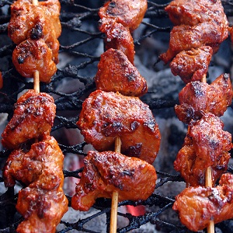

**Mshikaki Chicken/Beef**

Ingredients

* 1 teaspoon fresh ginger root, peeled and finely grated
* 1 or 2 cloves garlic, minced
* 1 small ripe tomato, peeled and crushed (or a tablespoon of tomato paste), (optional)
* 1/2 teaspoon tamarind paste, and/or a half-teaspoon of curry powder or similar spices,
* 2 tablespoons oil
* 2 tablespoons water
* black pepper, to taste
* salt, to taste
* 1 to 2 pounds boneless chicken/Beef ,cut into bite-sized cubes

Recipe Description:

Method:

* In a clean glass bowl, combine all marinade ingredients (everything except the Beef or chicken).
* Stir vigorously until everything is well mixed.
* Add the meat to the marinade, gently stirring to make sure the meat is covered.
* Allow to marinate for at least an hour, or overnight in the refrigerator.
* Place the marinated meat on skewers (if you like, chunks of onion or green pepper can be alternated with the meat).
* Cook over an outdoor grill over hot coals or in the oven until meat is done.
* Serve with Chapati or Rice or bread, as an appetizer or main course.Enjoy :)